Slack features:

Set reminders feature:

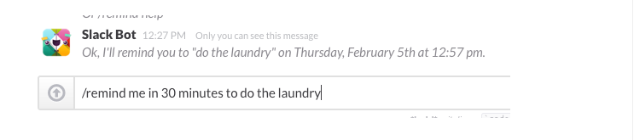

You can pin documents, so they can be accessed easily and found by all group members

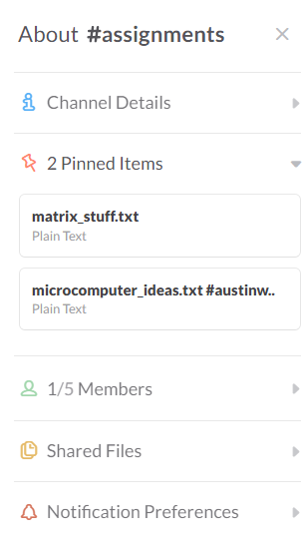

NikaBot-

Asks teammates what they did each day and then creates a gant chart of what each person has done and when they did it. Useful for showing off a timeline of your project and how you accomplished things.

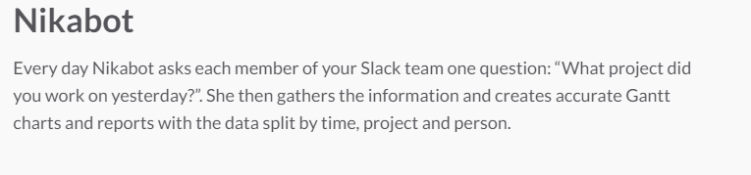

You can create polls.



Idea bot- list out ideas anytime you want, it stores them and team members can up vote or commented on.

Problem Statement:

To build an automated clock/ display which can be updated via a mobile or online application, using a display that we build or buy. The application must be secure so that no one can tamper with the output of the display. The display will be controlled by a microcontroller that will save all the displays information in case of power outages and must last at least one year. Also the display should be able to present messages that the faculty deems necessary.